Demo Pre-requisites
- Token available in your account profile at Oceans 3.0. To register for an account, go to this link. Note: Do not hit ‘Generate New Token’.
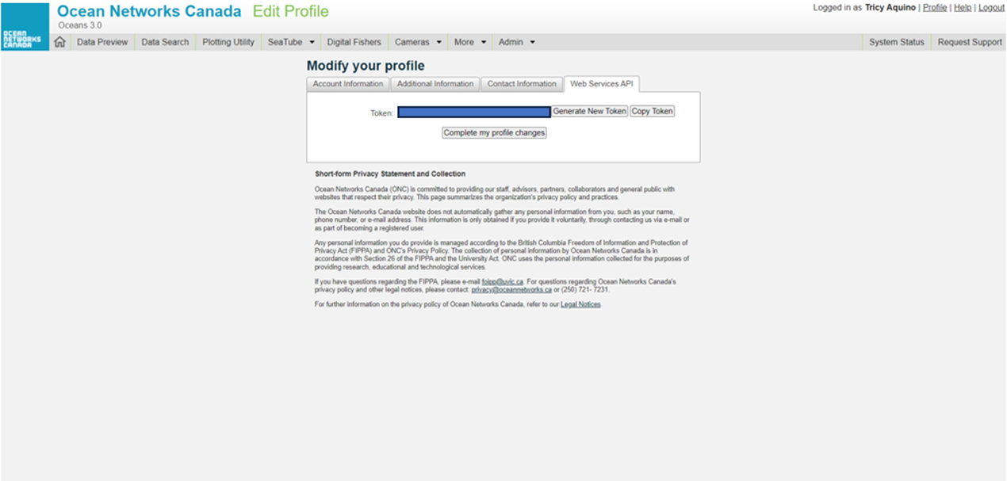

API Demo
- Sign up for a free account at Deepnote. You can use any email account. Please make sure to create a workspace before proceeding to step 2.
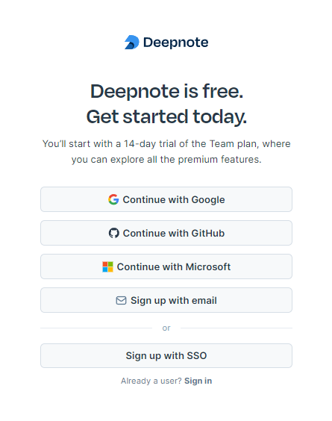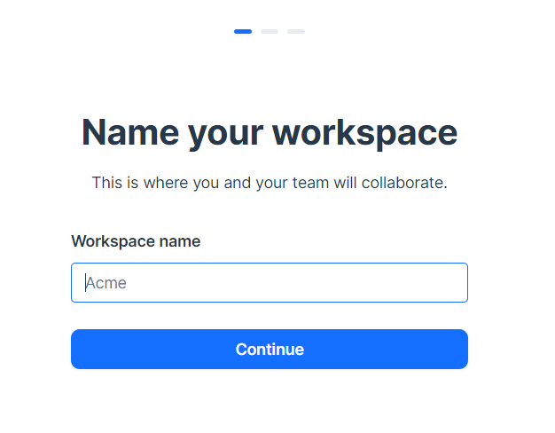

- Once you have created an account with a workspace, follow the steps below:
  - Click on this link – BMSC 2025 Participant Files.
  - On the right side of the screen, click on the meatball button (…) and choose duplicate project. See below:
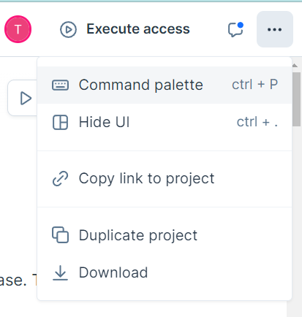
  - After clicking Duplicate project, you will be prompted with a screen asking for a workspace, choose your own workspace and hit the Duplicate project button:

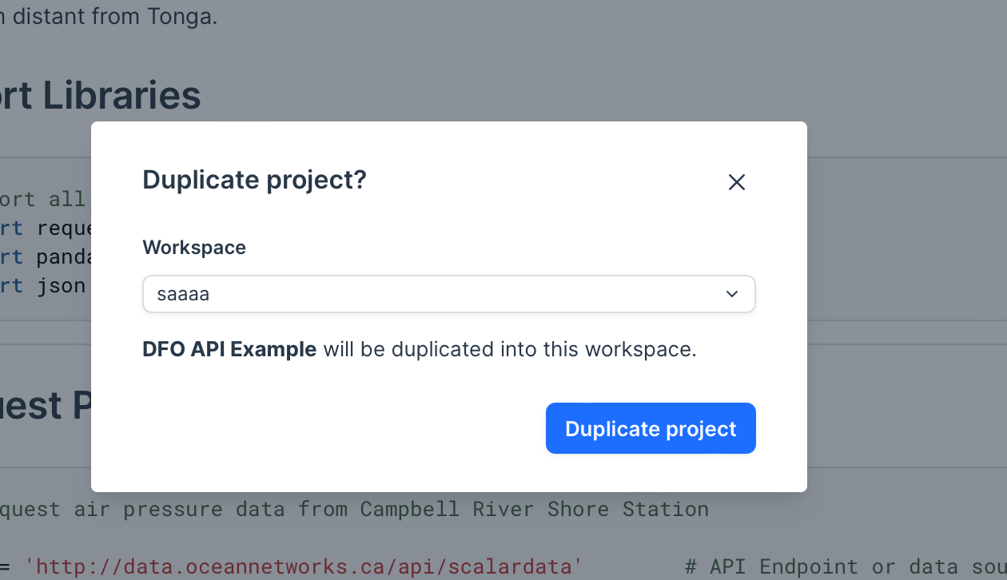

OpenAPI Demo

- Add JSON extension for different browser types (Firefox none required; JSON Formatter for Chrome, pretty JSON for Safari).

